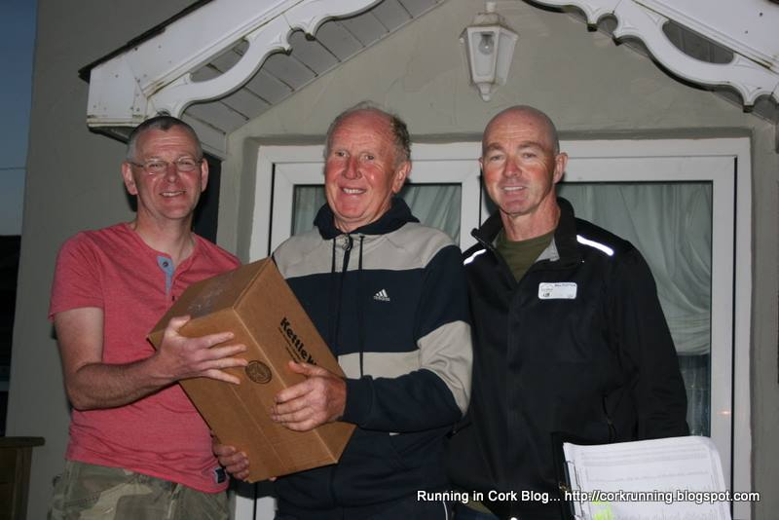
Background
Phil has been a member of East Cork ac since Liam O Brien told him so one summer evening years ago when registering for a race. Although he has been running since the tender age of 15 his best results have come of late in the over 65 category. We caught up with Phil for a chat about his training and attitude to running. It took a lot of persuasion to sway Phil to talk about his own running as he is more interested in how the younger generation are performing.
When did it all start?
My running career has really only taken off in the last 2 years but I have been in and out of running since my teenage years. Really the only reason Im up there now is because all the good fellas I competed against back in the day are after passing away.
Typical weeks training
My training has increased from 3 days a week to 5 over the last year or so. I dont do speed sessions but run hard when the body allows. The cliff route and the roads around the farm in Ballyandreen are the usual training haunts.
Why I run?
I just love tying up the laces and heading out the door, its great for the head. East Cork ac is a great club to be joined with the likes of Denis, Liam and Paul setting the standard for the younger generation.
Running Partners
Mostly I run by myself, I have been asked to come up to the track for speed sessions but I reckon Id be taken away in a van if I was caught doing that stuff at my age. I used to run with my daughter Niamh when she was underage but wouldn’t dream of going out with Sean, he’d leave me for dead.
Recent Achievements
After making a bold statement a few years back to a fellow competitor that I would break 20 minutes for 5km in the over 65 category. That’s exactly what I did in the Eimear Casey 5km encouraged to push myself that bit extra to keep in touch with fellow clubmate Denis McCarthy over the last kilometre. But Liam summed it up nicely afterwards when he told me I wasn’t a good runner when I needed to be.
Race Day
I don’t have any special routine on the day of a race. My pre race meal would be a tin of bins and two fried eggs. My attitude to racing is to give it all I’ve got, what’s the point in going to a race and jogging around.

When not competing Phil is a regular at local road and cross country fixtures, and puts the same level of enthusiasm into his support as he does his racing. Although he prefers to remain in the background and would be embarrassed at the thought of it, Phil’s lust for running, give it all attitude and top level masters performances makes him a club role model, albeit a reluctant one.

